NAAN MUDHALVAN

TITLE : WORDPRESS CREATION

USER NAME : B2F8931465B7584B39544A589B539B36

1.open word press

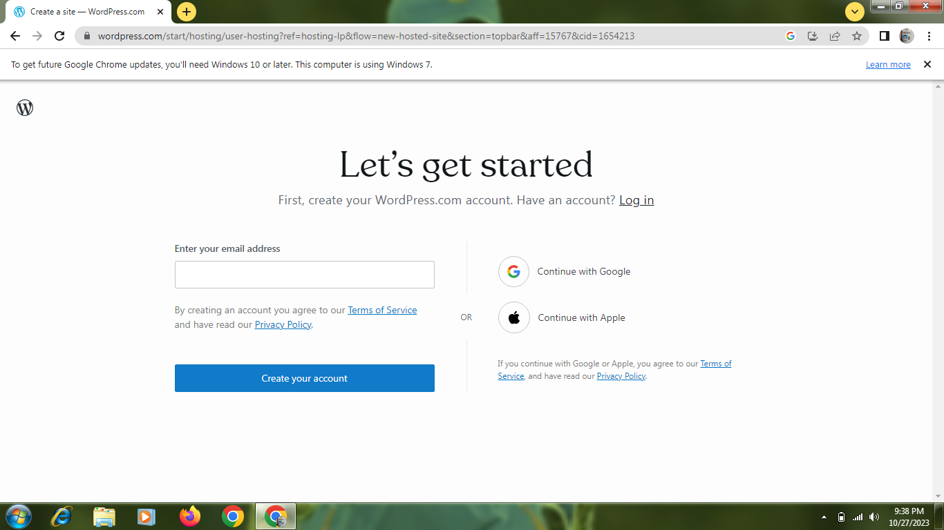

2.create a site and details

(1). Name

(2).site title

3.create a post

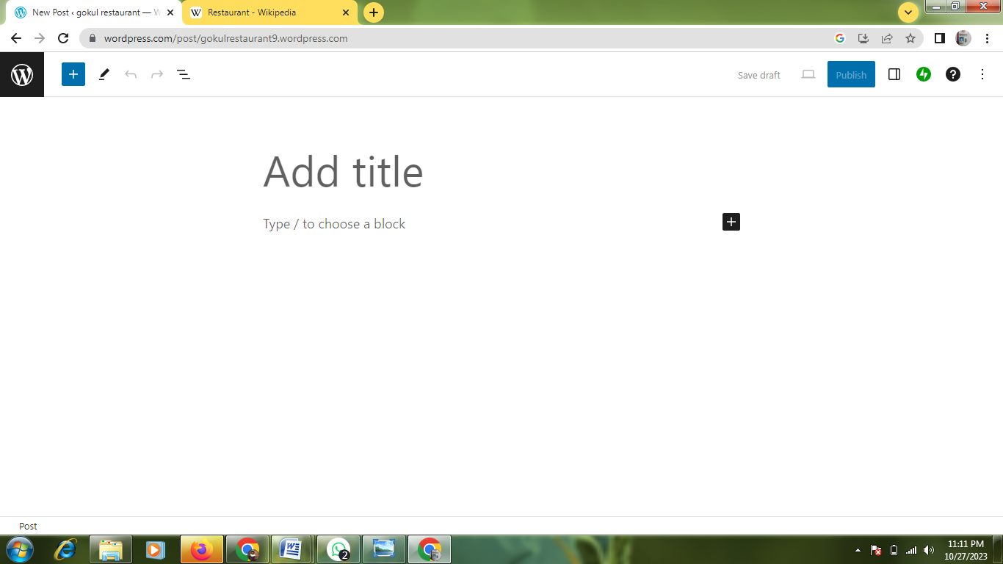

4.text the content

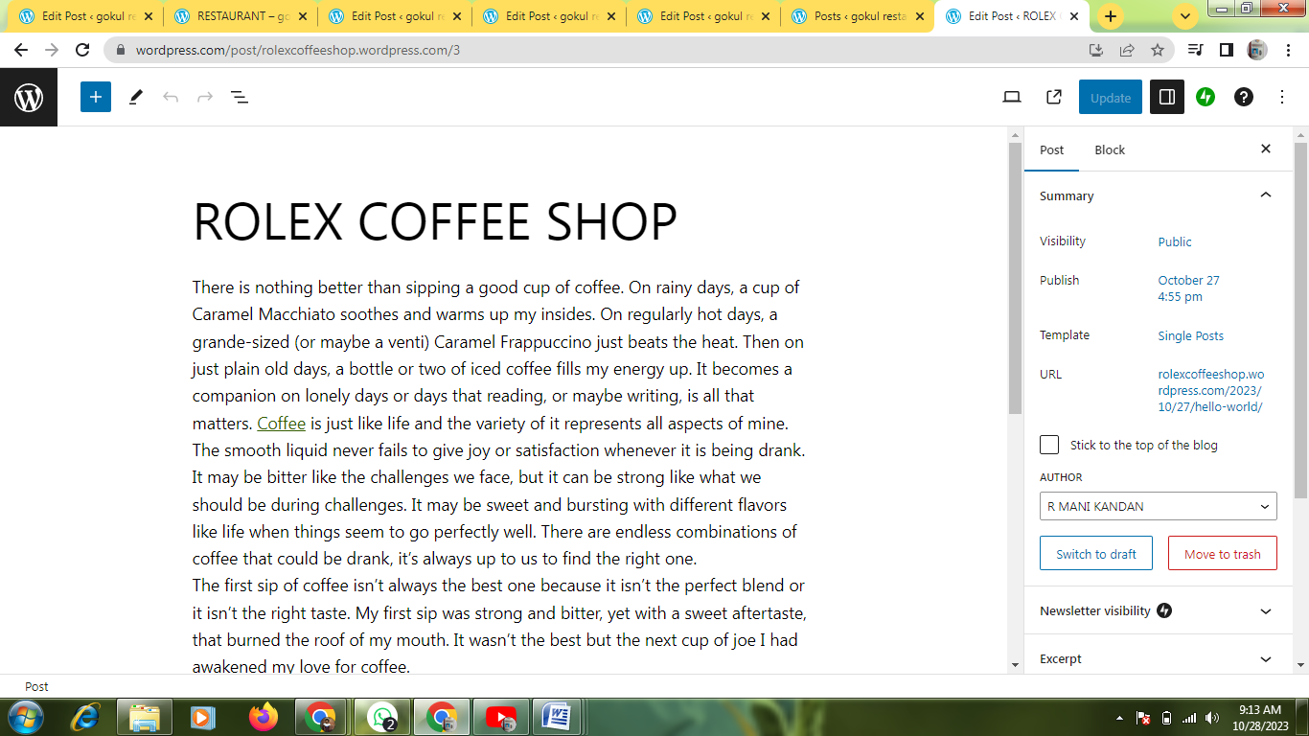

5.upload a post

